Modelling Of Software

Intensive Systems

Assignment 1: Modelica

1st Master computer science

2024-2025

Liam Leirs

Robbe Teughels

# Plant Model Creation:

We created a model of a plant that has a trolly with a rope attached to it. The goal of this evaluate both the pendulum and the trolly. More specific, the (angular) speed and the displacement. This can be tuned by the Damping factors *Dp* and *Dc*. For controlling the model, we use the control signal *u* that gives the desired displacement.

We tested the model with two intuitive tests: no displacement, set displacement.  
When we require the cart to stay fixed in place, the entire model stays fixed as we would expect. When we set the control system to a desired location, we see the cart move to the exact location, given some time. The pendulum reacts on the movement of the cart as required. Given these test, we assume that the model is representative to the real object for velocity and displacement.

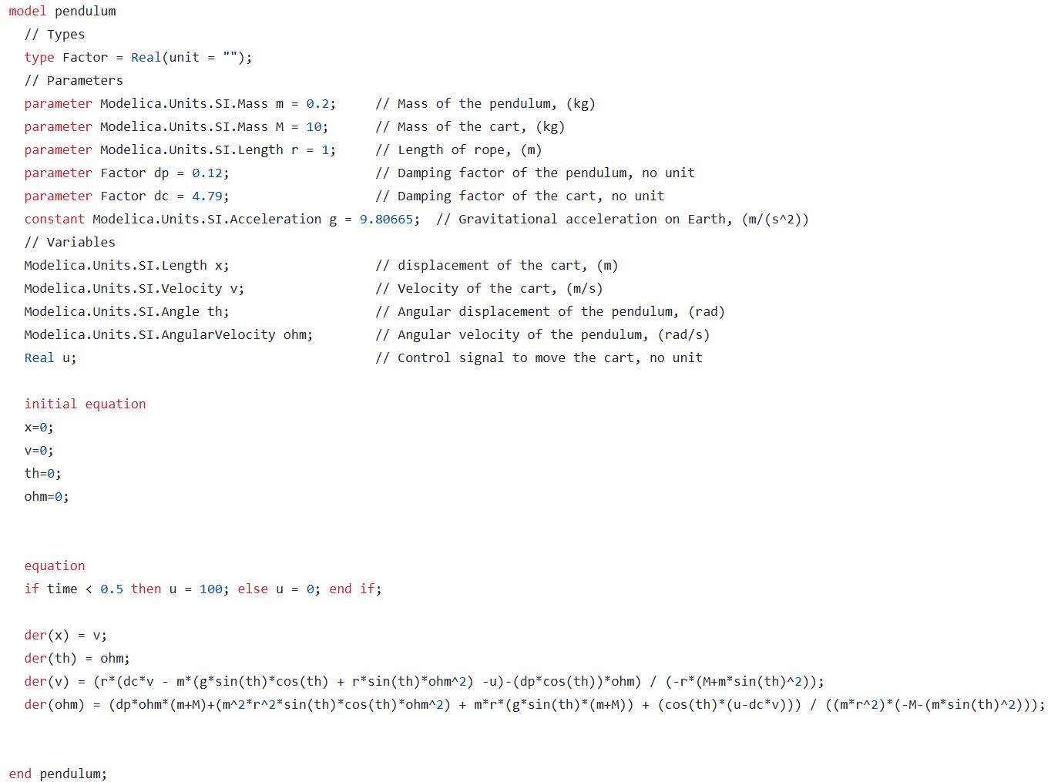

# Plant Model Calibration

Text here

# Controller Model Creation

Text here

# Controller Model Tuning

Text here